**HW 6**

**Problem 1**

1. According to the output below, it can be concluded that the interaction between breed and age is not statistically significant, with p-values all larger than 0.05.

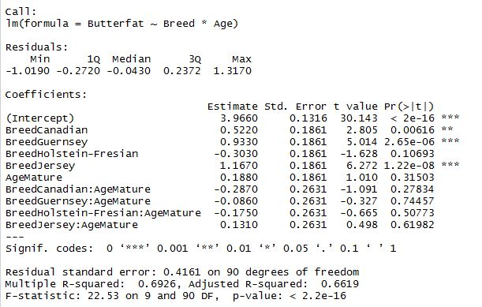

1. According to the output of Tukey’s pairwise comparison shown below, there’s a statistically significant difference between age groups, and there’s significant differences between various breeds except for between Jersey and Guernsey (p=0.077),

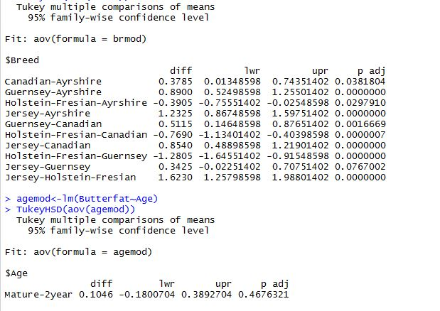

1. Based on the output shown in a, we can see that breed is a significant predictor of Butterfat, while age is not. Therefore, we’d better keep just breed in our model.

However, after plotting the diagnostics (shown below), we can find that the assumptions don’t seem to be met well.

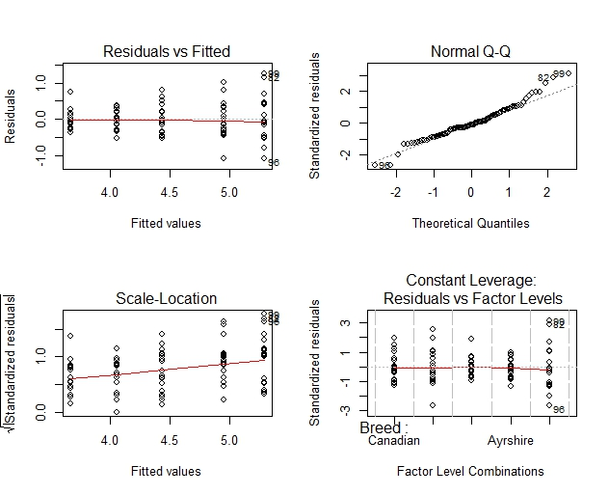

Therefore, we tried reciprocal, and as the diagnostics graphs below is showing, the assumptions of constant variance and normality assumptions are mostly met, in that lines in the Residual vs. Fitted and Scale-Locations plots are more flat, and the more points in the Q-Q plot are on the straight line compared with when reciprocal model was not used.

Most points do not have extreme influence except for 3 outliers, No. 48, 65 and 90. Generally speaking, assumptions are met in the model where the reciprocal of the response variable is taken.

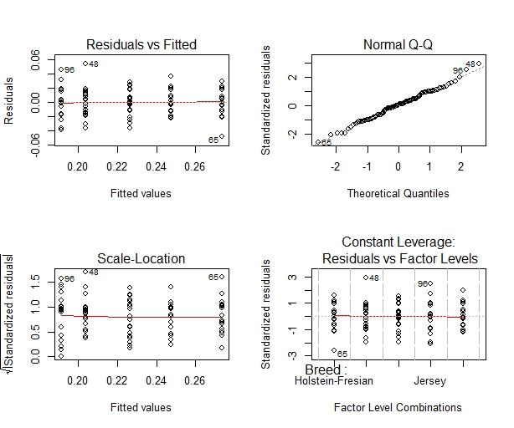

1. Based on the result of Tukey’s pairwise comparison using the reciprocal model, we can tell that Jersey is the best breed, and Guernsey is the second, both in terms of butterfat. However, the difference between the two is not significant, in that p=0.22. The same conclusion can be drawn using the result of Tukey’s pairwise comparison for the model where reciprocal is not taken (output can be found in b).

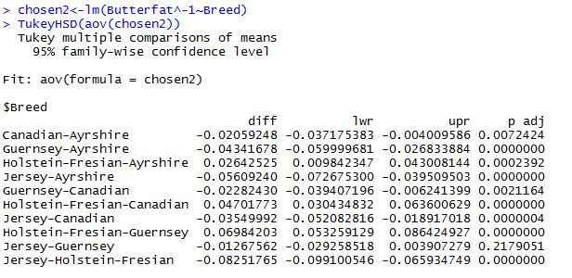

**Problem 2**

1. Summary of the data Football:

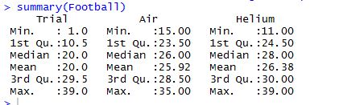

1. Because the two balls were kicked as pairs, the two kicks in each pair are not independent. Therefore, we should conduct a one-sample t-test, and the output is as below.

It turns out that there’s no statistically significant difference between the kick distances of the two kinds of balls, because the p-value is larger than 0.05.

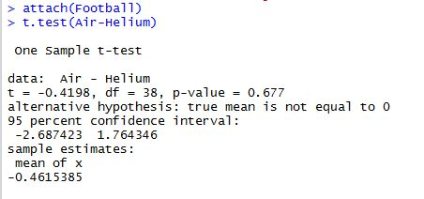

1. The simulation returned a p-value that equals 0.695, according to which our decision remains the same on the difference between the kick distances of the two kinds of balls.

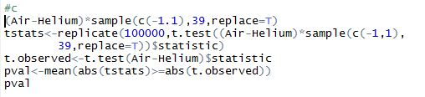

1. The histogram and the code are as below:

